**Website for MNC**

1. ERP Login portal

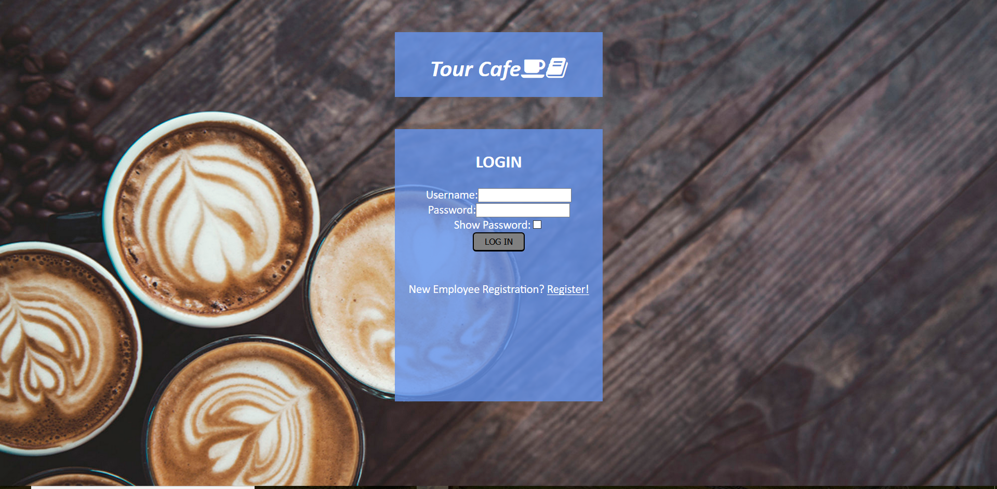

1. Employee Registration Portal

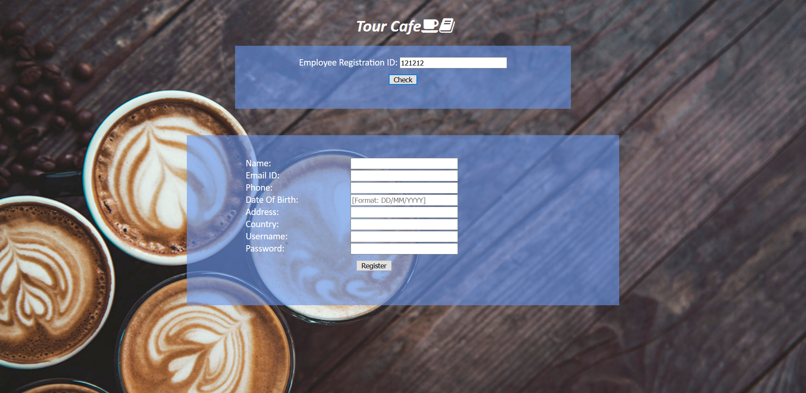

1. Website Homepage

(with fix on the screen navigation bar for page navigation from anywhere on the page)

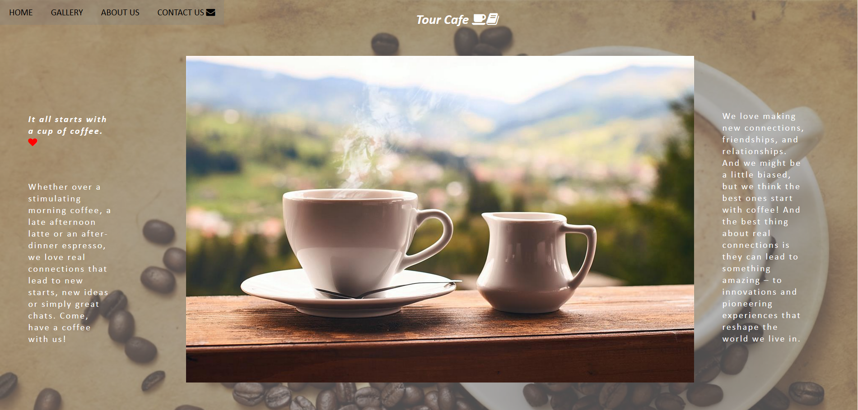

(with image slide show)

Extended



Gallery

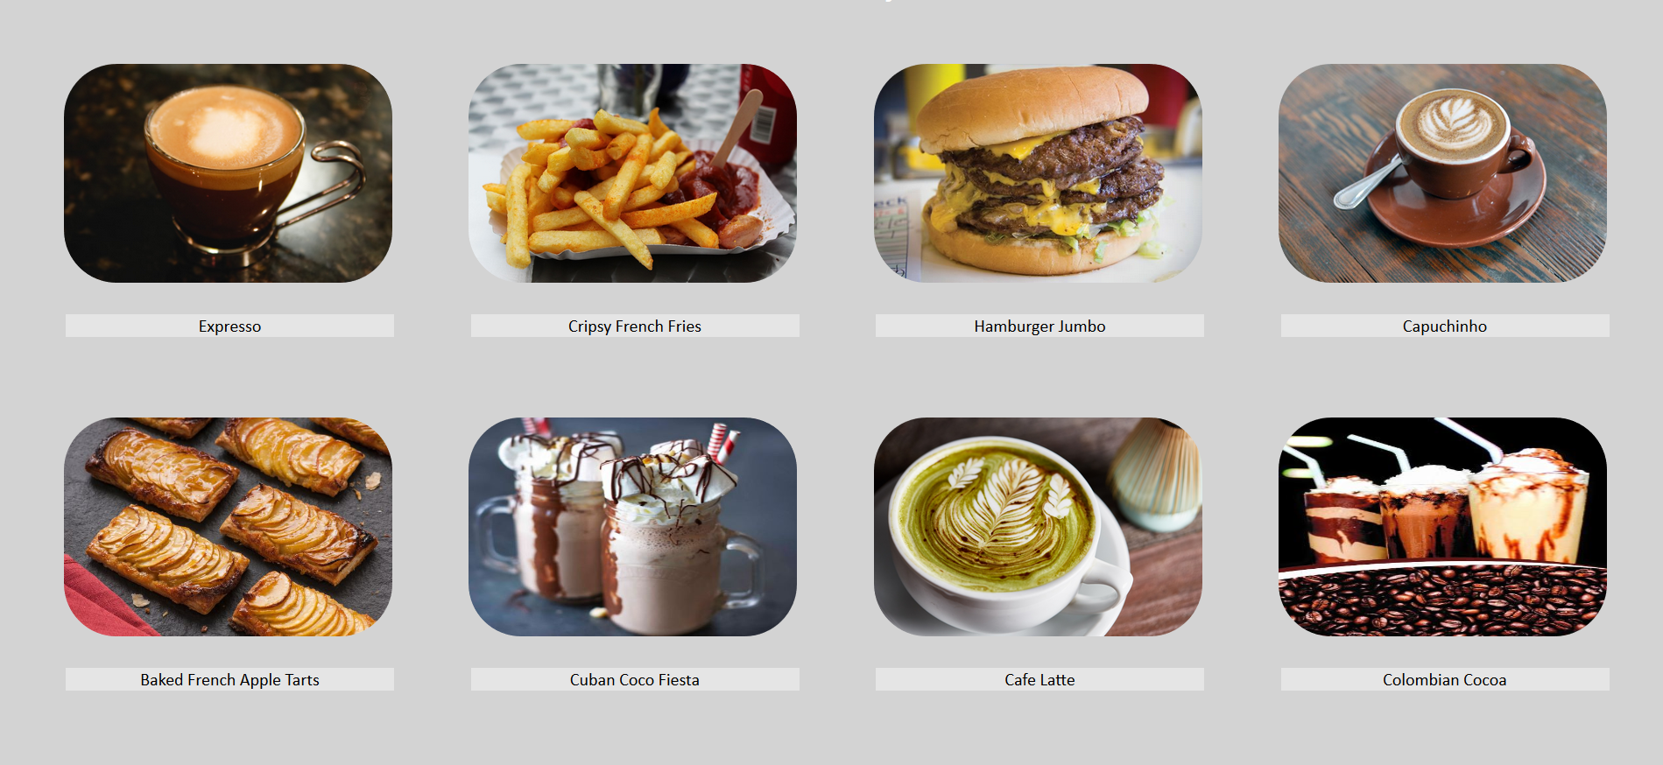

CSS style on Mouse cursor pointer focus

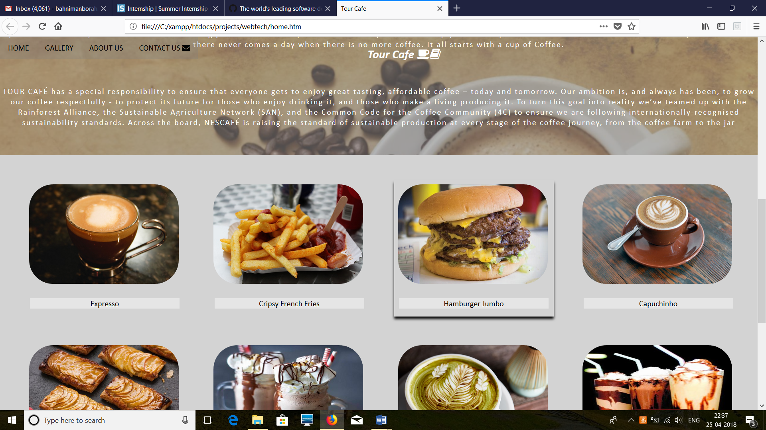

Contact Section

